Name | Arsh Raina
UID no. | 2021600053
Experiment No. | 5

AIM: | To Demonstrate the use of one-dimensional arrays to solve a given problem.
Program 1
PROBLEM STATEMENT : | Implement selection sort in an array.
ALGORITHM: | Step 1: Set min to the first location  Step 2: Search the minimum element in the array  Step 3: Swap the first location with the minimum value in the array  Step 4: Assign the second element as min.  Step 5: Repeat the process until we get a sorted array.
PROGRAM: | 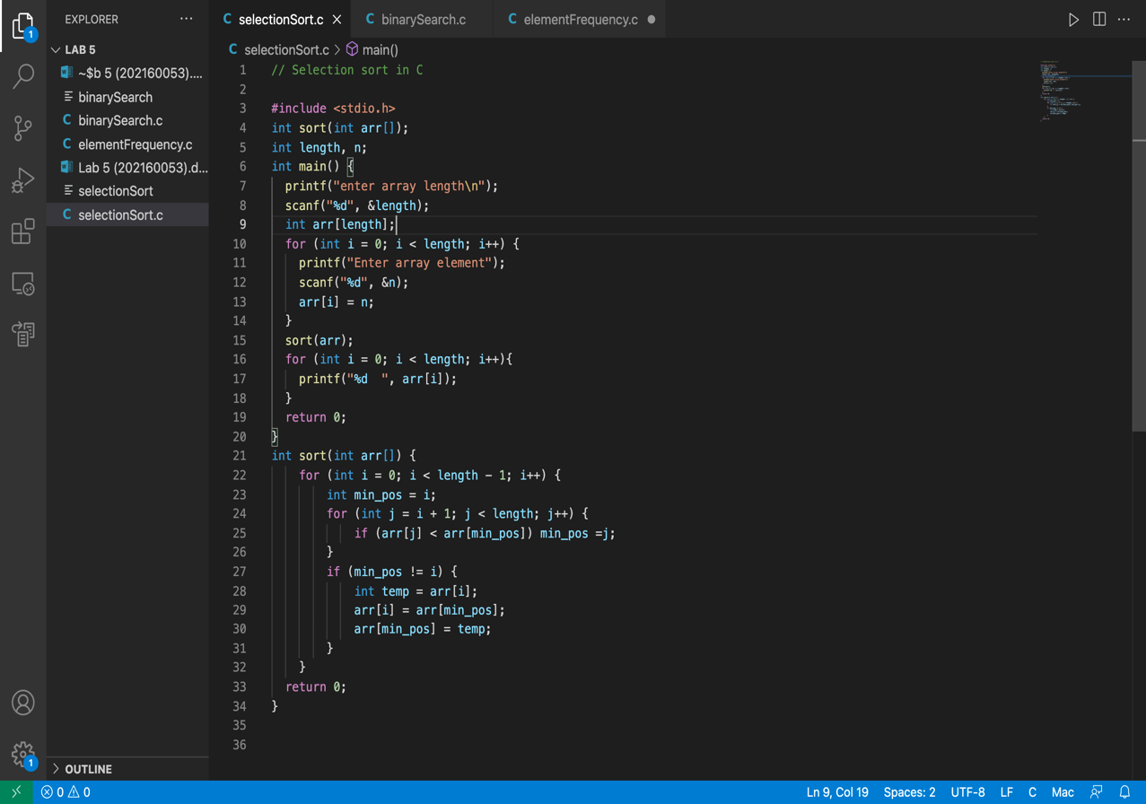
RESULT:
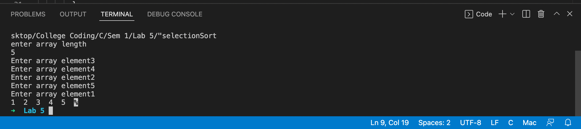
Program 2
PROBLEM STATEMENT : | Implement binary search in a sorted array.
ALGORITHM: | Step 1: Sort the array.  Step 2 : Find the middle element of array using , middle = (start + end) / 2 ;  Step 3 : If middle = element, return position of the element in the sorted array.  Step 4 : if middle > element, call the function with end = middle - 1.  Step 5 : if middle < element, call the function with start = middle + 1.
PROGRAM: | 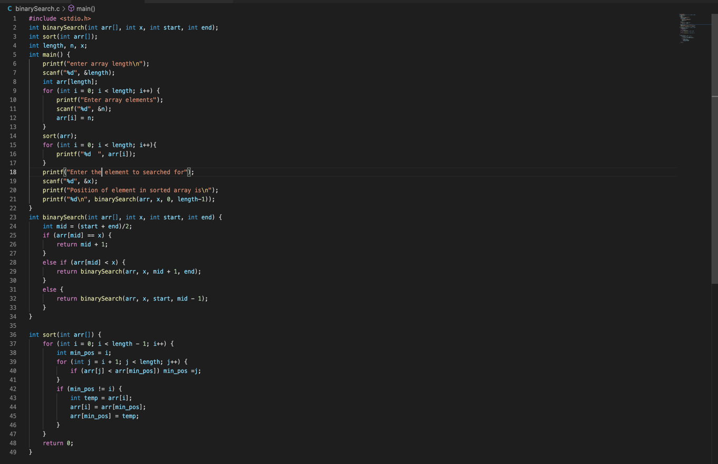
RESULT:
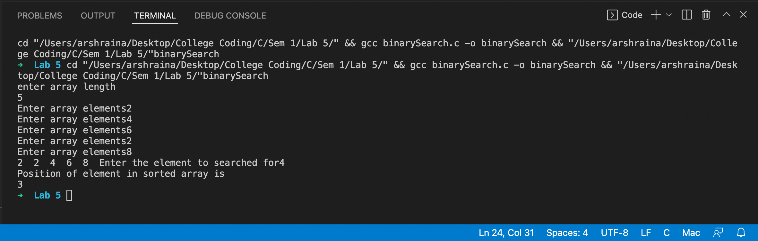
Program 3
PROBLEM STATEMENT: | Write a program in C to calculate frequency count of each number in ARRAY.
ALGORITHM: | Step 1: Input an array and define variable count equal to 1.  Step 2: Sort the array using selection sort algorithm.  Step 3: Run a for loop using variable i having values in range 0 to length of array-1.  Step 4: Inside the loop, if i equals length-1 or array element with index i is not equal to the element with index i+1, print the count.  Step 5: Inside the loop, else if array element with index i is equal to the element with index i+1, increase value of count by 1.
PROGRAM: | 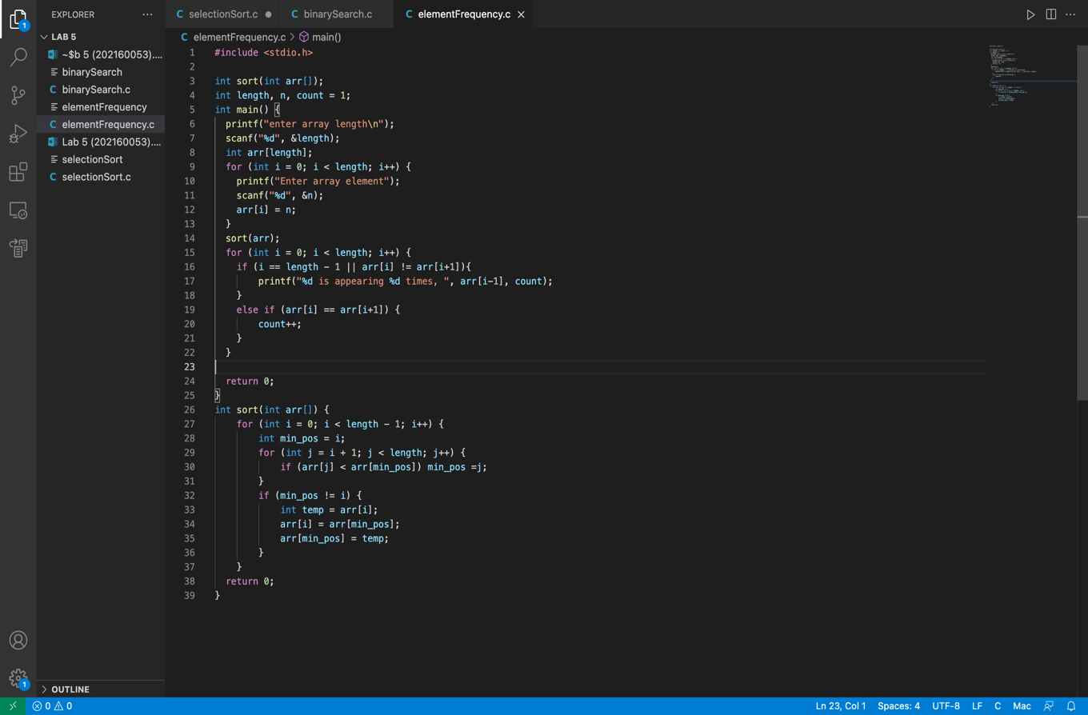
RESULT:
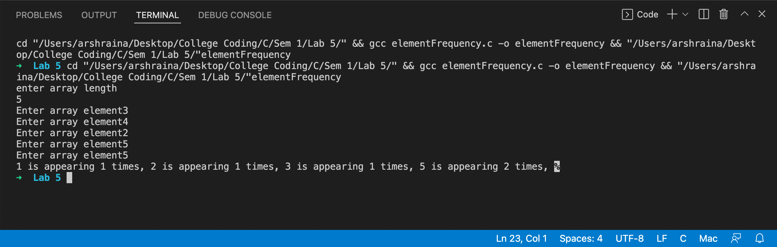
CONCLUSION: | Successfully used one-dimensional arrays to solve the given problems.

